Fight against COVID-19
Decontamination & Sanitizing Tunnel installed at Govt. Medical College, Jammu
By Jammu Municipal Corporation,
Department of Housing & Urban Development,
UT of Jammu & Kashmir

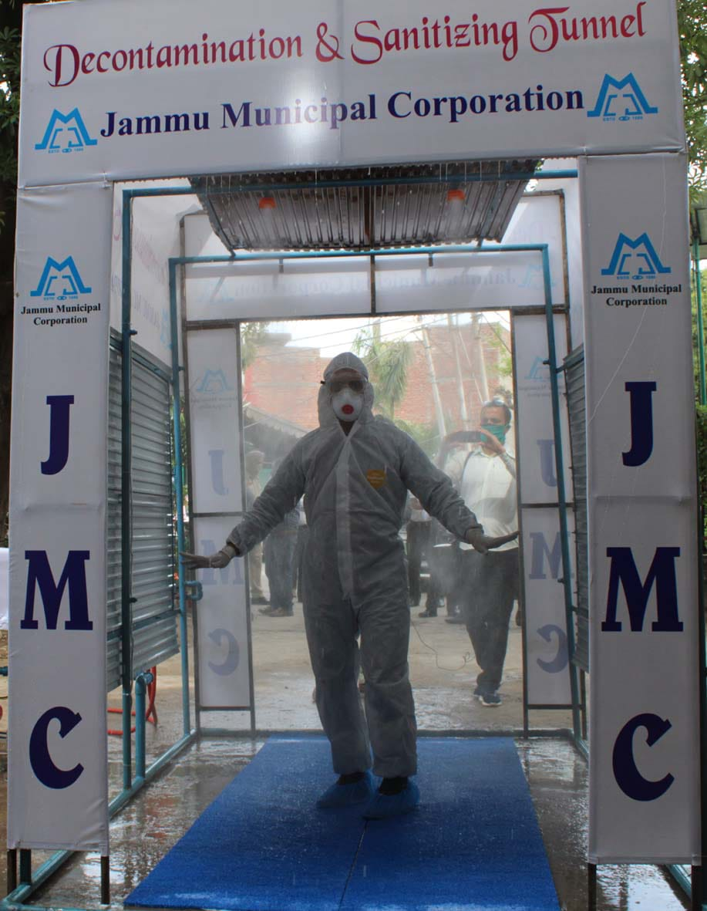

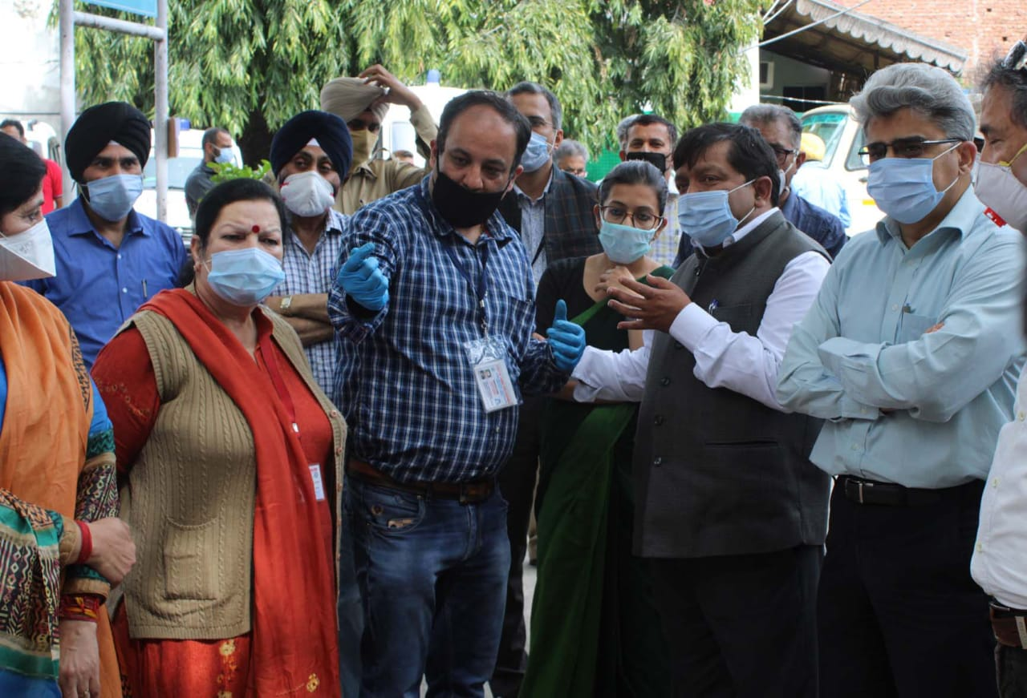

Portable Decontamination & Sanitizing Tunnel was installed at Govt. Medical College Jammu in presence of Sh. Deeraj Gupta, Principal Secretary to Govt., Housing & Urban Development Department by the Jammu Municipal Corporation. The Tunnel is installed with largest No. of nozzles facility (18) to be used as & when required and having handheld portable Sanitizing unit facility.

